Software Requirements Specification
for
Student-Faculty Interaction platform
Version 1.0 approved
Prepared by Piyush Jaiswal
NIIT UNIVERSITY
17.09.2016
Table of Contents
Table of Contents ii
Revision History ii
1. Introduction 1
1.1 Purpose 1
1.2 Document Conventions 1
1.3 Intended Audience and Reading Suggestions 1
1.4 Product Scope 1
1.5 References 1
2. Overall Description 2
2.1 Product Perspective 2
2.2 Product Functions 2
2.3 User Classes and Characteristics 2
2.4 Operating Environment 2
2.5 Design and Implementation Constraints 2
2.6 User Documentation 2
2.7 Assumptions and Dependencies 3
3. External Interface Requirements 3
3.1 User Interfaces 3
3.2 Hardware Interfaces 3
3.3 Software Interfaces 3
3.4 Communications Interfaces 3
4. System Features 4
4.1 System Feature 1 4
4.2 System Feature 2 (and so on) 4
5. Other Nonfunctional Requirements 4
5.1 Performance Requirements 4
5.2 Safety Requirements 5
5.3 Security Requirements 5
5.4 Software Quality Attributes 5
5.5 Business Rules 5
6. Other Requirements 5
Appendix A: Glossary 5
Appendix B: Analysis Models 5
Appendix C: To Be Determined List 6

Revision History
Name | Date | Reason For Changes | Version

Introduction

Purpose
The purpose of this document is to present a detailed description of the student-faculty Interaction web platform. It will explain the purpose and features of the system, the interfaces of the system, what the system will do and how will it react to external actions.

Document Conventions
Fonts bolded are the main topics of this SRS. The detailed descriptions of the topic are covered in smaller fonts. The underlines are important categories in the descriptions. TBD means To Be Determined as we don’t have the required information yet.

Intended Audience and Reading Suggestions
The intended audience for this SRS are both the developers and the users. The users can go through the product functions, user documentation and the operating environment.
The developers will find the design and implementation constraints to be more interesting.

Product Scope
This interaction system provides an online tool for faculties and students to interact in a much improved and better way. The faculty would be able to track efficiently the topics covered in a class and the student feedback which would give the faculty a better understanding of the intellectual status of a class regarding the subject. Many other features like request by student to meet the faculty, tracking of project progress would greatly improve the learning experience of the students.

Overall Description

Product Perspective
The context of this project is to improve the interaction between students and faculty and to remove the communication gap between students and faculty. This is a product in its own entirety and not an extension or derivation of other products.

Product Functions
Major functionalites of our product would be:

1. Tracking of each and every concept on the course handout by faculty & students.

2. Each and every concept can have different aspects as will be given by the faculty.
Ex: numercial, theoritical & application part etc.

3. Students can rate each topic form course handout including every aspect of the concepts
on the basis of their understanding.

4. Student can request to meet with faculty if they couldn't understand any topic. Faculty
can also take classes on any topic he/she finds is difficult to understand for the
students.

5. Faculty can view the feedback/rating student wise or topic wise to have a better
understanding of the feedback.

6. Students can update their progress on any project they might have undertaken which the
faculty would be able to track and advise on that.

7. If any student wants to meet the faculty, the faculty can enter the time slots which he
can afford and the student can choose among them.

8. The faculty can notify/poke any student if his/her attendance is below par and can also
notify him if he/she wants to meet the student.

9. The HOD of the department can track the progress of any course he is in-charge of.

10. The supension or rescheduling of any classes can be notified.

11. Students and faculty can provide feedback for the mid-sems as to which topic the
students need to work upon as well as the students can select any topic/question they
had problem in.

12. Students and faculty alike can provide feedback to each other.

13. Research or specialization area of the faculty in order for the students to approach
them for help or to undertake projects or research papers in that field.

14. An online link of the related topic that will give a deeper and better understanding of the same.

User Classes and Characteristics
There will be three types of user classes mainly:

- Student: The majority of the users will belong to this user class. This user class can see and communicate with certain members of faculty user class. The major functionalities will include the tracking of the concerned courses and some functionalities regarding those courses.

- Faculty: This user class will have access to students of the courses he is in charge of. This user class will add the topics covered and important things related to the course. This user class will be one of the major contributors regarding the use of the software.

- HOD: This user class is the head of the faculty class and hence will have the functionality to see the faculties and students involved in a course and their performance in the same.

Operating Environment
As it is a web application, the software will work on any device that has a decent browser and a good internet connection.
No other hardware specifications as such.

Design and Implementation Constraints
The availability of student attendance database is yet to be confirmed which might limit some of the functionalities.
A faculty cannot view the activities of other faculties which they are not related to. One exception might be when more than one faculty teaches the course.
The students will not be able to see the activities of other students and the faculties they are nit related to. The student can only see the average rating/feedback given to a particular topic.

User Documentation
TBD.

Assumptions and Dependencies
It is assumed that the college will approve of this method of interaction of the students and the faculty which is generally not the conventional way. It is also expected of the college to grant us the use of the attendance for each student.

External Interface Requirements

User Interfaces
The first screen will be the login screen where the users are supposed to login using their user-ids and passwords.

For students, this will lead to a page wherein the students can view the course handouts of different courses they are enrolled in. They can rate the topics from there and do various other things like request for meetings etc.

The faculty upon login will see the courses he/she is currently taking. The faculty can update the course handout from there with the date of the lectures. The faculty can also do various other things like view student’s feedback and take extra classes etc.

The HOD can view the courses he/she is in-charge of and the faculties under him. HOD can view the different courses of a faculty including the course handout and student feedback.

Hardware Interfaces
The supported device types can be any pc with a decent browser and good internet connection.
Other featured are TBD.

Software Interfaces
We will rent some server space to host our website. Our website will also access the databases of students, faculties and HODs. The service needed is a good internet connection.

Communications Interfaces
Web browser will be used as a communication interface. Other features are TBD.

System Features

System Feature 1
View course handout.
4.1.1 Description and Priority
The tracking of course handout is available. The faculty can update the course handout.
Actors involved: Student, Faculty, HOD.

4.1.2 Stimulus/Response Sequences
Faculty, HOD or the student are already logged in.

- User requests for the course handout.
- The course handout along with the topics covered and to be covered is displayed.
- Different aspects of the topics already covered can be viewed.
4.1.3 Functional Requirements
The user must have a decent browser and a god internet connection. Further requirements are TBD.

Priority: High

System Feature 2
Update course handout.
4.2.1 Description and Priority
Faculty can update the course handout based on the topics covered and the topics to be covered.
Actors involved: Faculty

4.2.2 Stimulus/Response Sequences
Faculty is already logged in.

- User requests to edit the course handout.
- Options to edit the topics covered and to be covered are displayed which can be edited.
4.2.3 Functional Requirements
The user must have a decent browser and a god internet connection. Further requirements are TBD.

Priority: High

System Feature 3
View student feedback.
4.3.1 Description and Priority
Student feedback of the topics covered based on their understanding.
Actors involved: Faculty, Students, HOD.

4.3.2 Stimulus/Response Sequences
Faculty is already logged in.

- User can view the feedback student wise or topic wise.
- Faculty can schedule extra class if he/she deems necessary.
4.3.3 Functional Requirements
The user must have a decent browser and a god internet connection. Further requirements are TBD.

Priority: High

System Feature 4
View research or specialization area of faculty.
4.4.1 Description and Priority
View research or specialization area of different faculties.
Actors involved: Faculty, Student, HOD.

4.4.2 Stimulus/Response Sequences
User is already logged in.

- View specialization or research area of faculty.

4.4.3 Functional Requirements
The user must have a decent browser and a god internet connection. Further requirements are TBD.
Priority: Low

System Feature 5
View meeting request.
4.5.1 Description and Priority
View meeting request by other user classes.
Actors involved: Faculty, Student, HOD

4.5.2 Stimulus/Response Sequences
User is already logged in.

- Can view the meeting requests.
- Can view the reason for the request.
- Can accept or decline request.
4.5.3 Functional Requirements
The user must have a decent browser and a god internet connection. Further requirements are TBD.

Priority: Medium

System Feature 6
View project progress.
4.6.1 Description and Priority
View different projects and their progress.
Actors involved: Faculty, Student.

4.6.2 Stimulus/Response Sequences
User is already logged in.

- Can view different projects and their progress
- Can advise on project if the faculty wants.
4.6.3 Functional Requirements
The user must have a decent browser and a god internet connection. Further requirements are TBD.

Priority: Medium

System Feature 7
Students can give feedback for topics already taught.
4.7.1 Description and Priority
Give feedback regarding topics already covered in class on the basis of understanding.

Actors involved: Student.

4.7.2 Stimulus/Response Sequences
User is already logged in.

- Give feedback for topics covered on the whole.
- Rate different aspects of the topic.
4.7.3 Functional Requirements
The user must have a decent browser and a god internet connection. Further requirements are TBD.

Priority: High

System Feature 8
Schedule meeting or extra class.
4.8.1 Description and Priority
Can schedule meeting with other user classes.
Can schedule extra classes id he feels necessary.
Actors involved: Faculty, Student.

4.8.2 Stimulus/Response Sequences
User is already logged in.

- Can schedule meeting requests with another user class.
- Has to enter reason for request.
- Can schedule extra classes.
4.8.3 Functional Requirements
The user must have a decent browser and a god internet connection. Further requirements are TBD.

Priority: Medium

System Feature 9
Update project progress.
4.9.1 Description and Priority
Update the progress of the particular project.
Actors involved: Student.

4.9.2 Stimulus/Response Sequences
User is already logged in.

- Update progress of particular project.
- View faculty advice on the project.
4.9.3 Functional Requirements
The user must have a decent browser and a god internet connection. Further requirements are TBD.

Priority: Medium

System Feature 10
View examination feedback.
4.10.1 Description and Priority
View feedback regarding any examinations that have been conducted
Actors involved: Student, Faculty, HOD.

4.10.2 Stimulus/Response Sequences
User is already logged in.

- Can view feedback of the examinations already conducted.
- Students can view the questions faculty advises the students to work upon.
- Faculty can view the questions in which students faced problems.

4.10.3 Functional Requirements
The user must have a decent browser and a god internet connection. Further requirements are TBD.

Priority: Low

System Feature 11
Give feedback for the examinations conducted.
4.11.1 Description and Priority
Give feedback for the recent examinations conducted.
Actors involved: Student, Faculty.

4.11.2 Stimulus/Response Sequences
User is already logged in.

- Can give feedback for the examinations conducted.
- Faculty can select questions in which student needs to work upon.
- Students can select questions in which they faced probems.
4.11.3 Functional Requirements
The user must have a decent browser and a god internet connection. Further requirements are TBD.

Priority: Low

System Feature 12
Update their research or specialization area.
4.12.1 Description and Priority
Faculty can update their research and specialization area.
Actors involved: Faculty.

4.12.2 Stimulus/Response Sequences
User is already logged in.

- Update research area or specialization area.
4.12.3 Functional Requirements
The user must have a decent browser and a god internet connection. Further requirements are TBD.

Priority: Low

FUNCTIONAL REQUIREMENTS IN TABULAR FORM

IDENTIFIER FOR THE REQUIREMENT | SHORT NAME OF REQUIREMENT | SHORT DESCRIPTION
REQ 1 | View Course Handout | The tracking of course handout is available. The faculty can update the course handout, mainly the topics that have already been covered and the topics that are to be covered.  Actors involved: Student, Faculty, HOD.
REQ 2 | Update Course Handout | Faculty can update the course handout based on the topics covered and the topics to be covered.  Actors involved: Faculty
REQ 3 | View Student Feedback | Student feedback of the topics covered based on their understanding including different aspects of the topic.  Actors involved: Faculty, Students, HOD.
REQ 4 | View Research or Specialization area of faculty | View research or specialization area of different faculties which they already have or currently are pursuing.  Actors involved: Faculty, Student, HOD.
REQ 5 | View meeting request | View meeting request by other user classes including the reason for the request and have the option to accept or decline it.  Actors involved: Faculty, Student, HOD
REQ 6 | View project progress | View different projects that the students have undertaken and their progress. Students can only view their own projects.  Actors involved: Faculty, Student.
REQ 7 | Give feedback for topics taught. | Give feedback regarding topics already covered in class on the basis of understanding.  Actors involved: Student
REQ 8 | Schedule meeting or extra class | Can schedule meeting with other user classes. Have to specify the reason for such meetings. Faculty can also schedule extra classes if he feels is required for a topic.  Actors involved: Faculty, Student.
REQ 9 | Update project progress | Update the progress of the particular project that the student has undertaken.  Actors involved: Student.
REQ 10 | View examination feedback. | View feedback regarding any examinations that have been conducted  Actors involved: Student, Faculty, HOD.
REQ 11 | Give feedback for examinations. | Give feedback for the recent examinations conducted. Student and faculties have different way for giving feedback.  Actors involved: Student, Faculty.
REQ 12 | Update research or specialization area. | Faculty can update their research and specialization area if it has changed.  Actors involved: Faculty.

USE CASE DIAGRAM
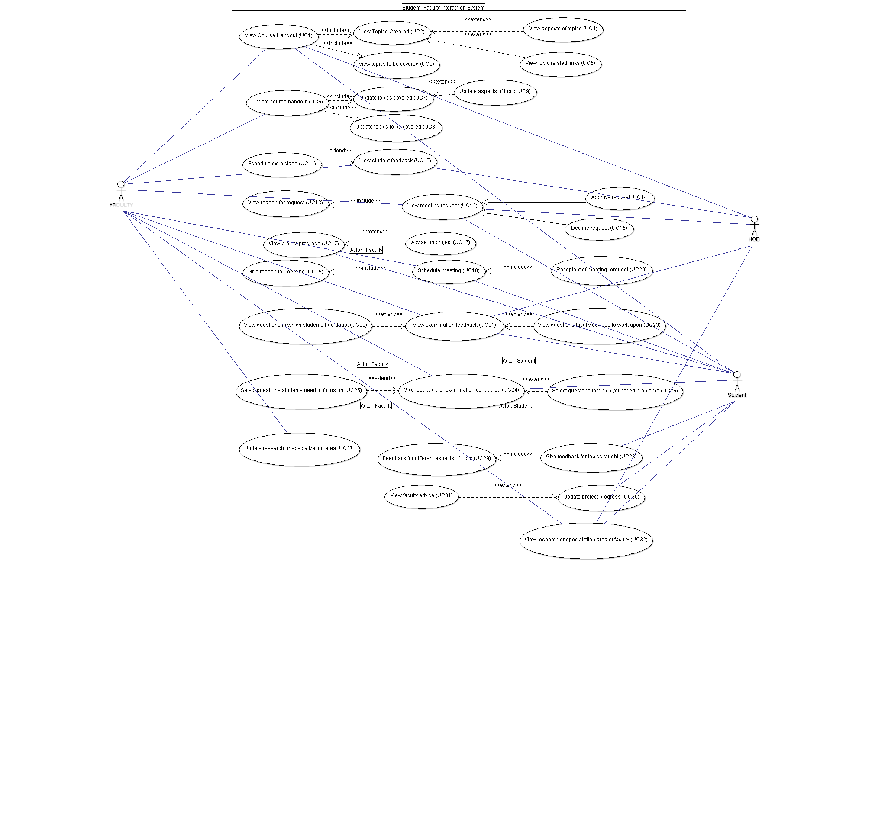

Other Nonfunctional Requirements

Performance Requirements
A good browser and a good internet connection is required to use the interaction platform smoothly and in its full capacity. No such hardware requirements as such. As it is a web platform, it will run on most operating systems. Other performance requirements are TBD.

Safety Requirements
Possibility of data loss in case of browser crashes or when the server is down.

Security Requirements
User Id and a password will be required for a particular login for every type of user class that is student, faculty and HOD. The data viewed or entered by one student cannot be accessed by another student. Only the concerned faculties and the HODs are allowed to access it. Faculty cannot view or access the activities of other faculties or the HODs. He can only access his data and the students who are related to his course. The HODs can view the data of the faculties and in turn the students under him.

Software Quality Attributes
The platform is highly flexible and portable as it can be accessed by any computer and on any operating system with the correct user Id and password.

Business Rules
TBD.

TABULAR FORM OF NON-FUNCTIONAL REQUIREMENTS

IDENTIFIER FOR THE REQUIREMENT | SHORT NAME OF REQUIREMENT | SHORT DESCRIPTION
REQ 15 | Performance requirements. | A good browser and a good internet connection is required to use the interaction platform smoothly and in its full capacity. No such hardware requirements as such. As it is a web platform, it will run on most operating systems. Other performance requirements are TBD.
REQ 16 | Safety requirements. | Possibility of data loss in case of browser crashes or when the server is down.
REQ 17 | Security requirements. | User Id and a password will be required for a particular login for every type of user class that is student, faculty and HOD. The data viewed or entered by one student cannot be accessed by another student. Only the concerned faculties and the HODs are allowed to access it. Faculty cannot view or access the activities of other faculties or the HODs. He can only access his data and the students who are related to his course. The HODs can view the data of the faculties and in turn the students under him.
REQ 18 | Software quality attributes. | The platform is highly flexible and portable as it can be accessed by any computer and on any operating system with the correct user Id and password.
REQ 19 | Business Rules. | TBD..

Other Requirements
TBD.
Appendix A: Glossary
TBD.
Appendix B: Analysis Models
TBD.
Appendix C: To Be Determined List

